Edible York Express – December 2014

Ho Ho Ho! (Hoe! Hoe! Hoe!) And a merry Christmas to one and all. We have turned through the cusp of the year, and from here on in, the days are lengthening and the seed catalogues are beckoning to us. Our vegetable gardens are resting, nourished by leaf moulds, green manures, fresh heaps of manure. And we are all resting too, in some capacity or another. But that doesn’t stop us from keeping you up to date with our happenings…

Barbican Bed Flourishes
The FOBBEY (Friends of Barbican Bed Edible York) neighbourhood group has been tending these beds all through the summer and continues to visit most Saturdays at 11am to tidy up the beds after Friday night revellers. Winter leaves are flourishing, especially the landcress and plantain leaves: please help yourselves to some extra winter vitamins! In January and February we will be pruning the fruit bushes and replanting the strawberries that have produced lots of runners. We always welcome new gardeners to join us.

Please telephone Jennifer on 01904 638874 or email jennifer@edibleyork.org.uk.
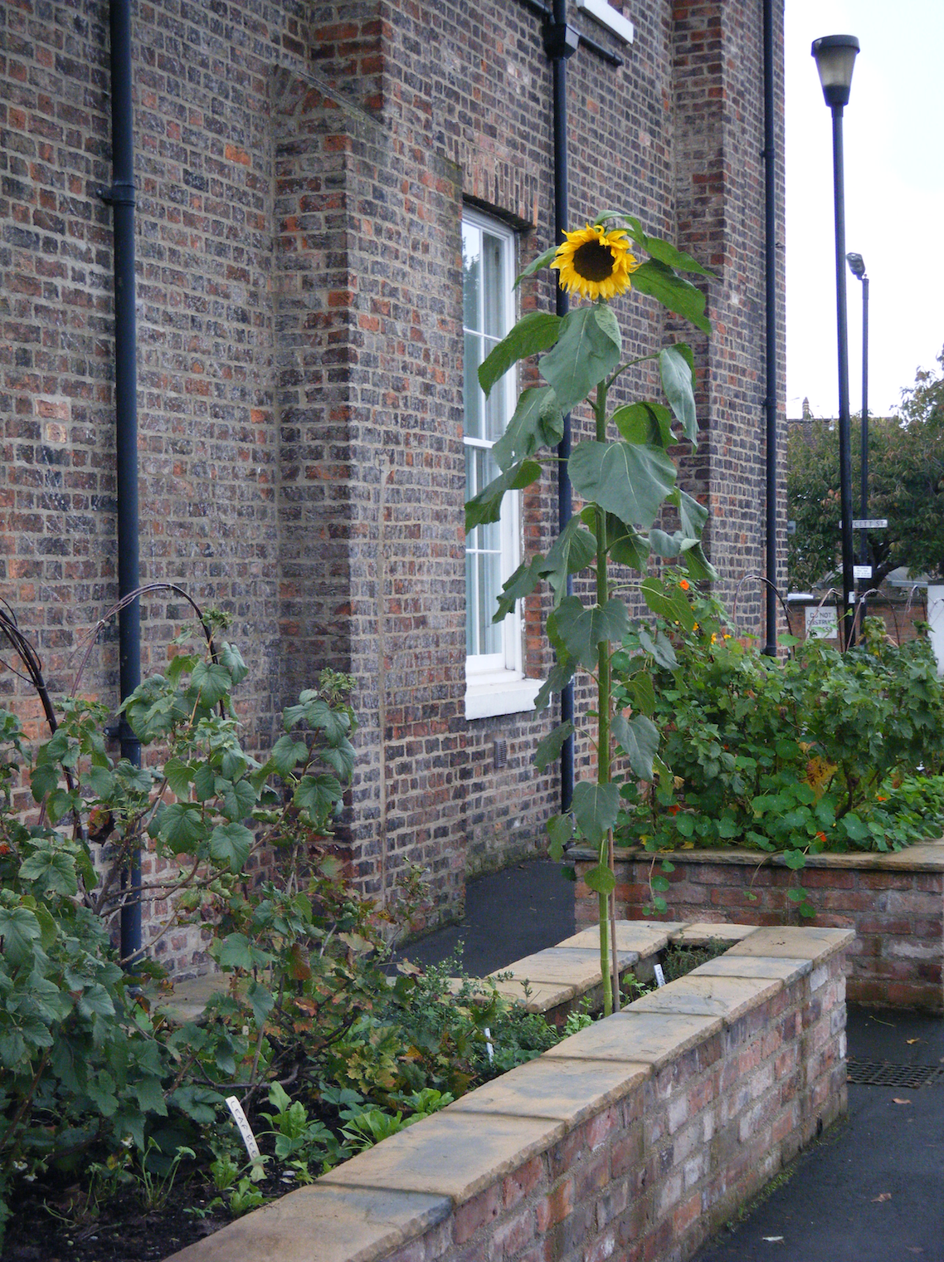

Local funding update

Thanks to all those that voted for Edible York when the local Waitrose store selected us as one of its monthly charities – we were awarded £264! Every little helps (hang on, I think that’s a competitor’s strapline…), and this money will go directly towards buying new seeds and trees for public veg gardens across York in 2015. This month one of Waitrose’s charities is our good friend, Feed 5000 (working to support long term unemployed and disadvantaged through horticultural training): give them your vote if you happen to be in the store.

After a presentation to York Ainsty Rotary Club (one of three local Rotary groups), Edible York has also been awarded £100 to support the next phase of The York Orchard (planting edible trees and providing maintenance training with communities across the City). Hip! Hip! Hoorah!

We will be working on some more sizeable funding applications in early 2015 to develop bigger pieces of work around the York Orchard and community growing.

We will be holding another fun-filled fundraising day at St Crux on Tuesday April 14th – please put the date in your diaries and let us know if you would like to help out on the day, or have anything to donate (we’ll send out another call after Christmas for all those unwanted presents!).

Edible York’s Big Annual Meet & Eat: Saturday 21st March
We have traditionally brought Edible Yorkies together in early Spring, to plan for the year to come, inspire each other with projects new and old, share fine food and do the official AGM bit.

This year is no exception – and we’re looking towards Saturday March 21st for this shindig. Come one, come all.

Food for Life Partnership and York Edible Schools
Schools across the City continue to bloom and blossom, led by an inspiring band of committed teachers. A number of these schools will be recognised with Food for Life Partnership awards at an auspicious event on March 13th. If you’d like your school to get involved with this work in York (which supports schools to integrate a healthy food culture through cooking, growing and strong links to farms), please contact Chloe Smee (erstwhile Edible York chair and founder) at CSmee@soilassociation.org

One of the projects being developed by Poppleton Road Primary School is an eye-catching public veg bed in front of the school. Led by the local families, this veg garden will be a productive demonstration of the school’s commitment to good food. Let us know if you’re local and want to get involved, and we’ll pass you their way!

York Edible Schools has produced a helpful growing guide for schools, which will be heading out to schools in January 2015 to get children and young people all fired up for the next growing season.

Door 84 Grow & Cook course
The Grow & Cook project will be running a free 13-week course (in, erm, growing and cooking) on Friday mornings from Jan 30th – 1st May. Please contact Kath and Lucy at growandcook.door84@outlook.com for more information and eligibility criteria.

A Very Merry Yuletide to you all…. Chloe, on behalf of Edible York

PS. Don’t forget to compost some of your wrapping paper!
http://www.recyclenow.com/reduce/home-composting/faqs/making-compost-faqs#35

PPS. Or perhaps make some leftover cake:
http://www.bbcgoodfood.com/recipes/1826702/leftover-veg-and-orange-cake

